NAME VIKRAM KUMAR

ID BIT-23F-026

SUBJECT AI

LAB TASK 6

DATE 10-12-2024

task1.Write a Python function that takes a number as input and returns the sum of its digits.

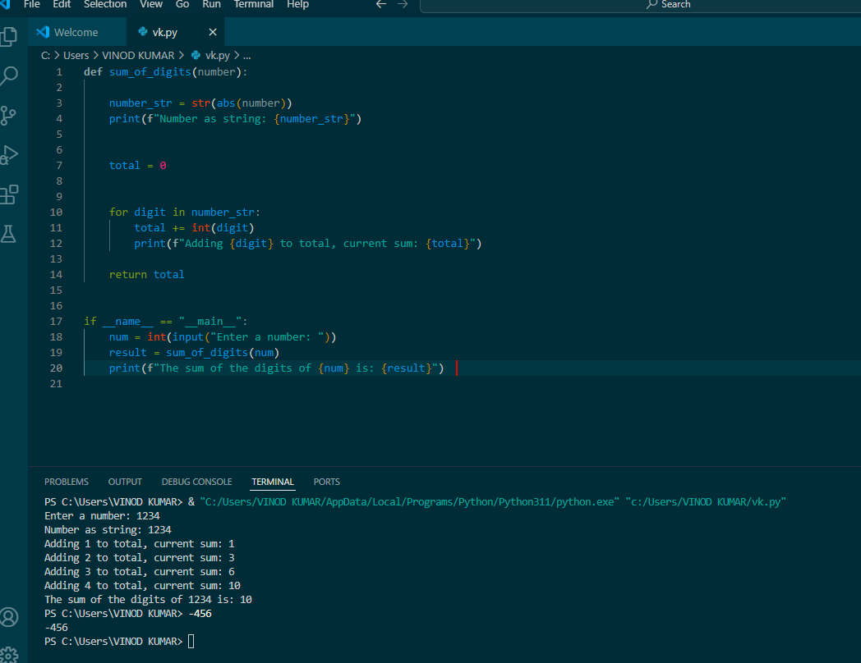

Write a Python function that takes a sentence as input and returns the number of words in it.

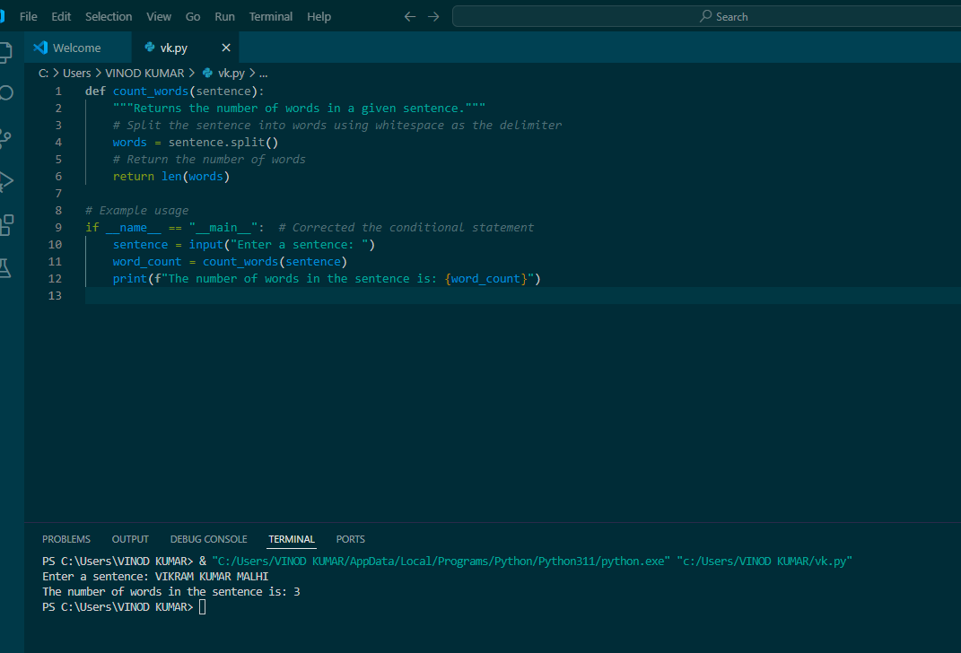

Write a Python function that takes an integer and returns whether the number is even or odd.

